Rock & Roll Group Lessons
Beginner 2
5 Years Old and Up
12 Sessions /$258 (Materials Included)
$25 Registration Fee for New Students Only
Every Thursdays 6:00-7:00pm
** No Makeup lessons or Refund for any Missing Class**
Enroll Now

Piano Group Lessons
Beginner 2
5 Years Old and Up
12 Sessions /$258 (Book Included)
$25 Registration Fee for New Students Only
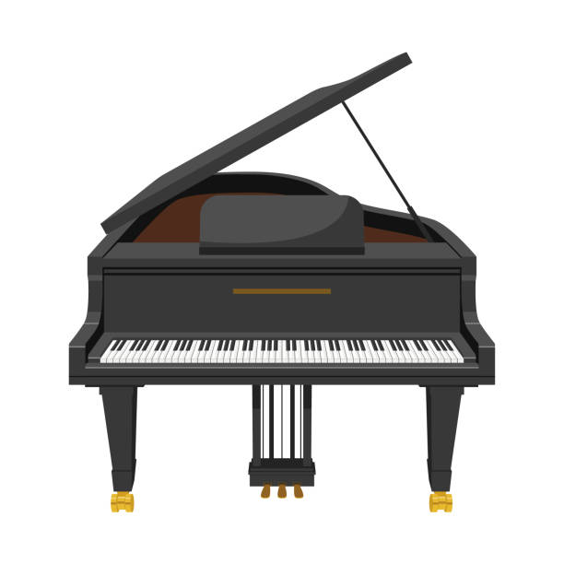
Every Fridays 6:00-7:00pm
1/6/23-3/24/23
** No Makeup lessons or Refund for any Missing Class
Enroll Now
Calligraphy Lesson
儿童书法课
5 Years Old and Up
$88/Monthly (Materials Included)
$25 Registration Fee for New Students Only
Wednesdays 5:00-6:00pm
** No Makeup lessons or Refund for any Missing Class

Enroll Now
Chinese Traditional Painting Lesson
儿童水墨画
5 Years Old and Up
$88/Monthly (Materials Included)
$25 Registration Fee for New Students Only
Mons or Thurs 5:00-6:00pm
** No Makeup lessons or Refund for any Missing Class

Enroll Now
Chinese Heritage School
Enroll Now
5 Years Old and Up
Monday to Friday 3-7pm
$165/weekly, or $45/day + ($60 books)
Curriculums
- Chinese Conversation Class: Every Day – Writing, Reading, Speaking
- Chinese Calligraphy Class: Wednesdays
- Chinese Traditional Painting Class: Mondays and Thursdays
- Piano Group Lesson: Fridays
- Guitar Group Lesson: Tuesdays
More Information Please Check with Office

